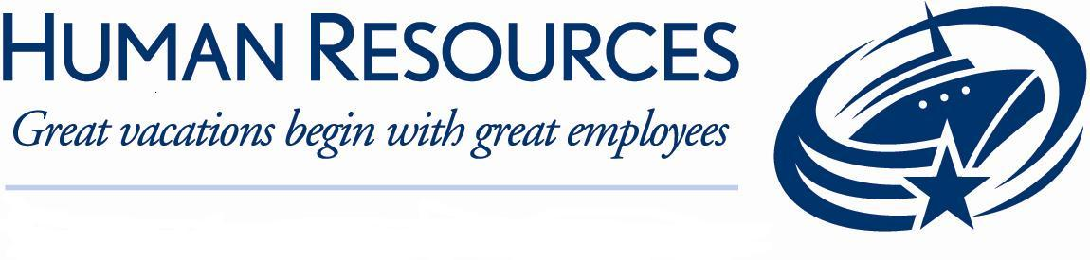

Job Description

Job title  Public Area Attendant |  | Date  11/08/18
Job code  PAA | Prepared By  Curt Roberts – Lead Public area specialist
Business Unit/Department  Guest Services/Hotel Operations | Approved By  Antonie Starke – Director of housekeeping
Position Reports To  Cleaning Specialist  Assistant Cleaning Specialist | FLSA Status (For Global Compensation Use Only)  ___ Exempt ____ Non-Exempt
Direct Reports | Job Family (For Global Compensation Use Only)  Job Family

Position Summary: This Position maintains all public areas, crew Public Areas, outer deck (Pools and Jacuzzis) and all public restrooms, in a clean and orderly condition by performing essential duties and responsibilities described underneath. The Public Area attendants could be used in different areas on a rotation bases.
Essential Duties and Responsibilities:
All duties and responsibilities are to be performed in accordance with Royal Caribbean International’s, SOP’s, SQM standards, USPH guidelines, environmental, and safety policies.

In accordance with Royal Caribbean International’s Royal Way Experience, each employee exemplifies friendly, passionate, committed behavior at all time. This consists of physical and verbal interactions with guests and fellow shipboard employees.

Each shipboard employee may be required to perform all functions in various service venues throughout the ship.

- Operates steam cleaning equipment/machines, scrapers, brooms and a variety of hand and power tools. Uses a variety of cleaners and chemicals depending on the cleaning needs. Mixes water and detergents in a container to prepare cleaning solutions, according to specifications.
- Cleans public bathrooms, elevators, offices and crew corridors in areas not under the responsibility of a BASO.
- Cleans carpet, upholstery, floors, walls, ceilings, draperies, windows, and area accessories to remove effects of smoke, water and other damages such as dirt, soot, stains, mildew, and excess water and moisture.
- Sprays or fogs carpet, upholstery, and accessories with fabric conditioners and protectors, clean and sanitize. Dusts furniture and washes windows, walls, ceilings, woodwork, and door panels. Polishes brass and other metal fixtures.
- Notifies management of all malfunctions, safety, security, maintenance-related issues, etc.
- Maintains cleaning supplies and equipment in good working order. Makes recommendations for the requisitions of supplies and equipment when needed.
- Maintains current knowledge of the ship’s regular events and special functions by reviewing all available data (daily Compass, etc.) in order to provide guests with accurate information to answer questions.
- Assist food service personnel in the collection of soiled glasses, china, cutlery, etc., throughout the vessel and transports to designated collection areas.
- Empties and cleans wastebaskets and ash trays and transports trash to disposal area.
- Transports guests’ luggage to assigned areas during embarkation and disembarkation.
- Attends meetings, training activities, courses and all other work-related activities as required.
- Maintains a safe, clean and sanitary pool area for guests and shipboard employees, including the turf. Follows procedures to open and close the pool each day. Assist Life Guard on duty to attach and detach net over the pool.
- Enforces Pool Deck lounge chairs reservation SOP’s.
- Makes sure that wet floor are constantly mopped/dried.
- Observes general safety regulations are followed, responds to any type of emergency by dialing 911.
- Maintains deck furniture in a clean and orderly fashion. Stacks chairs and transports to assigned areas. Inspects deck chairs on a daily basis for condition of straps (if damaged, heavily stained or missing, replace immediately), and inspects for leg caps (if missing replace immediately).
- Issues / tracks towels for guests according to the Pool Towel Policy. Folds towels on port days and transports towels to the towel station.
- Cleans and sanitizes pool area and spa showerheads on a monthly schedule. Follows shipboard cleaning schedules to ensure periodic deep cleaning of the pools and Jacuzzis.
- Performs a variety of duties when the pool area is closed.
- Children Swimming Pool Life Jackets should be monitored, cleaned and sanitized on a daily basis.
- Performs related duties as required. This position description in no way states or implies that these are the only duties to be performed by the shipboard employee occupying this position. Shipboard employees will be required to perform any other job-related duties assigned by their supervisor or management.

Qualifications:

- Minimum one year previous cleaning experience, preferably in a 4 or 5 star hotel.
- Knowledge of proper cleaning techniques, requirements and use of equipment.
- Knowledge of proper chemical handling.
- Ability to apply customer service skills, according to Royal Caribbean International’s SOP’s, when interacting with guests and coworkers.
- Completion of high school or basic education equivalency preferred.

Language Requirements:

- Ability to speak English clearly, distinctly and cordially with guests is a required.
- Ability to read and write English in order to understand and interpret written procedures.
- This includes the ability to give and receive instructions in written and verbal forms and to effectively present information and respond to questions from guests, supervisors and fellow crew.

Physical Demands:
- While performing the duties of this job, the shipboard employee is regularly required to stand, walk, use hands to touch, handle, or feel, reach with hands and arms, talk or hear, and taste or smell. Specific vision abilities required by this job include close vision, distance vision, color vision, peripheral vision, depth perception, and ability to adjust focus.

- All shipboard employees must be physically able to participate in emergency lifesaving procedures and drills. Full use and range of arms and legs as well as full visual, verbal and hearing abilities are required to receive and give instructions in the event of an emergency including the lowering of lifeboats. Ability to lift and/or move up to 50 pounds.

